AI Automated Transaction Categorization System
This document explains the complete design, architecture, methodology, and implementation of the offline AI-based transaction categorization system built for the contest. The goal of the project is to create a highly accurate, autonomous, and secure categorization engine that developers can use inside their own infrastructure without depending on external cloud APIs.

Understanding of Problem & Objectives:
Financial apps and banks must automatically categorise raw transactions (e.g., “Starbucks,” “Amazon,” “Shell Fuel”) into categories like Dining, Shopping, or Fuel. The challenge lies in noisy merchant names, unseen vendors, and strict privacy policies that prevent cloud-based solutions.
My goal is to design an autonomous, high-accuracy, offline AI system that classifies financial transactions securely, transparently, and efficiently—giving developers full control without external APIs.

1.Technology Stack
The system is developed entirely in Python, which provides a powerful and flexible environment for machine learning and data automation workflows. The user interface is implemented using Streamlit, chosen for its ease of use and ability to create interactive dashboards without requiring a traditional frontend framework. The backend logic is built around a custom inference engine called SafeTransactionPipeline. This pipeline integrates text preprocessing, embedding generation, time feature extraction, and model inference into a single unified process.
For the machine learning components, the project uses Sentence-Transformers’ MiniLM-L6-v2 model, a lightweight embedding model that converts merchant names into dense semantic vectors. This model is extremely compact and optimized for CPU inference, making it ideal for offline environments. The classification engine is powered by XGBoost, a gradient-boosting algorithm chosen for its robustness, high accuracy, and low-latency inference. XGBoost handles noisy and variable merchant data effectively and runs efficiently even on modest hardware.
For data processing, libraries such as Pandas and regular expressions are used extensively to clean merchant names, format timestamps, and prepare datasets for model training and inference. The system also integrates pdfplumber to extract structured data from digital PDF bank statements. All persistent configuration data—such as the list of transaction categories—is stored in a simple taxonomy.json file, giving developers the ability to modify category labels without editing code. All transaction data extracted from PDFs or batch uploads is stored in CSV format locally, ensuring complete control over data isolation and privacy.

2. System Architecture
The system is designed with a clean separation between the user interface, preprocessing pipeline, embedding layer, classifier, and output visualization. The Streamlit frontend serves as the main interaction point for users. Within this interface, users can enter merchant names and timestamps manually, upload PDFs containing transactions, or edit the taxonomy categories directly.
When a user enters transaction details, the request is passed to the SafeTransactionPipeline. This pipeline first performs text cleaning on the merchant name to remove unnecessary characters, normalize casing, and ensure that the embedding model receives high-quality input. The timestamp is parsed and converted into numerical time features such as hour of day, weekday, day of month, and month, all of which help differentiate spending patterns. These preprocessing steps ensure consistency across both synthetic and real-world inputs.
The cleaned merchant name is then passed to the embedding model (LightEmbed MiniLM), which generates a 384-dimensional vector capturing the semantic meaning of the merchant. Meanwhile, the time features form a supplementary numeric vector. These two vectors are combined in a feature-fusion step, creating a single unified representation of the transaction. This fusion of semantic and behavioral information significantly boosts prediction accuracy.
The fused vector is then passed to the XGBoost classifier, which produces the final prediction: the transaction category and a confidence score. The system returns this prediction to the Streamlit interface, where it is displayed to the user. Finally, the user may view insights, graphs, or edit taxonomy settings through the same interface. This modular architecture ensures that every component—preprocessing, embedding, classification, storage, and UI—operates cohesively but independently, making the system easy to maintain and extend.

3. Data Model & Storage
To train the system effectively, a synthetic dataset containing ten thousand transaction records was created. This dataset reflects realistic Indian spending patterns, covering a wide range of merchants from small local shops to major retail and service brands. Each data record consists of a merchant name, timestamp, amount, and category. The timestamps follow natural transaction patterns, and the merchants reflect typical consumer and business spending activity. These synthetic records provide the diversity necessary for the model to learn useful representations without relying on real financial data.
During inference, the system requires only two essential fields: the merchant name and the timestamp. The system does not use or store any sensitive data such as personal identifiers, bank account numbers, payment IDs, or detailed transaction narratives. Only the essential input fields required for category prediction enter the pipeline, making the system inherently privacy-friendly.
The system’s category structure is defined in a simple JSON file named taxonomy.json. This file contains the list of categories used to label transactions, such as Food & Beverage, Groceries, Fuel, Transport & Travel, and others. The category list can be updated by the user directly from the Streamlit interface, allowing administrators to rename, reorganize, or standardize category labels without retraining the model—as long as the number of categories remains the same.
The trained ML pipeline is stored in a single serialized file named full_pipeline.pkl, which contains the embedding model reference, the feature-generation logic, and the XGBoost classifier. Storing the pipeline as one file ensures consistency across environments and simplifies deployment. PDF-extracted transactions are saved in CSV files locally, allowing them to be used later for batch predictions or analysis.

4. AI / ML / Automation Components
The core of the AI system is the SafeTransactionPipeline, which orchestrates the full flow from raw input to final prediction. The pipeline begins with merchant name cleaning, which removes punctuation, normalizes whitespace, and converts the text to lowercase. This step ensures that different variations of the same merchant—such as "Starbucks #221" and "STARBUCKS MUMBAI"—are treated similarly.
After cleaning, the timestamp is parsed into a standard datetime structure. From this datetime, the system extracts four behavioral features: hour of purchase, day of week, day of month, and month. These features help capture user behavior patterns, such as weekend shopping, monthly bill payments, or frequent morning coffee purchases.
The embedding layer converts the merchant name into a dense numerical vector using the MiniLM-L6-v2 Sentence Transformer model. This model generates a semantic representation of merchant names, allowing the system to understand that "Dominos Pizza" is similar to "Pizza Hut" or that "Reliance Trends" is conceptually related to “Lifestyle Stores.” These embeddings significantly improve generalization to unseen merchants.
The feature fusion step combines the semantic embedding and the behavioral features into a single vector, which becomes the input to the classifier. XGBoost, the chosen classifier, excels at capturing complex decision boundaries between categories. It produces a probability distribution across all possible categories and selects the one with the highest score as the final prediction. The output also includes a confidence score, providing transparency into the model’s certainty.
We have trained on various models from those XGBOOST got high macro F1 score. Hence we have used XG BOOST.
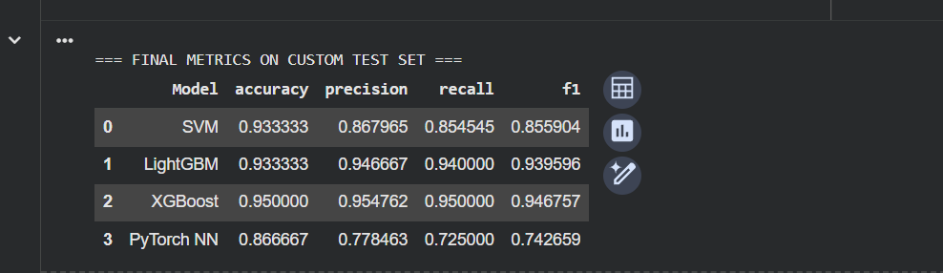

5. Security & Compliance
The system is designed with a strong focus on privacy and compliance. Since all operations are conducted locally, no transaction data ever leaves the user’s device. There are no network calls or external API dependencies, meaning sensitive financial information remains fully under the user’s control. This architectural choice eliminates risks associated with cloud storage or third-party data leaks.
The model itself only requires two fields—merchant and timestamp—and the system avoids storing or processing any sensitive personal information such as account numbers, UPI IDs, card numbers, or identifiable user data. The PDF extractor also sanitizes input by discarding unnecessary lines or metadata, ensuring that only essential data fields are retained.
All configuration files, including taxonomy.json, are stored locally and can be edited only by authorized users. The absence of external dependencies and minimal local storage of transaction data results in a secure, compliant, and audit-friendly architecture.

6. Scalability & Performance
The system is designed to scale both vertically and horizontally while maintaining excellent performance even on modest hardware. The embedding model is lightweight, enabling fast generation of semantic vectors on CPU-only systems. The XGBoost classifier is optimized for rapid inference and has a very low memory footprint, enabling predictions within milliseconds.
For batch operations, the system uses vectorized computations that can process thousands of transactions efficiently, making it suitable for finance dashboards, personal budgeting applications, or enterprise reconciliation tools. The Streamlit interface is stateless and supports deployment in containerized environments such as Docker, enabling scalability across servers or cloud environments if desired.
The modular architecture ensures that components such as the embedding model, classifier, taxonomy, and preprocessing logic can be upgraded independently. This flexibility allows the system to evolve without disrupting existing deployments.

7. Future Enhancements
A future extension planned for the system is the integration of a more advanced PDF extraction engine that includes OCR capabilities. This enhancement would allow the processing of scanned documents, images, or low-quality statements that cannot be extracted using standard text-based parsing.
Another major enhancement is the future integration of MongoDB-based human feedback loops. This feature would allow users to submit corrections whenever the model predicts an incorrect category. These corrections would be stored in a feedback database and used periodically to retrain or fine-tune the model. This approach ensures that the system adapts to emerging merchants, evolving behaviours, and individualized spending patterns over time.
Additional enhancements include the possibility of adding explainability modules using SHAP values, clustering new merchants for automatic category suggestions, and expanding taxonomy management capabilities.

8. Architecture and Pipeline Diagram:
System Architecture:
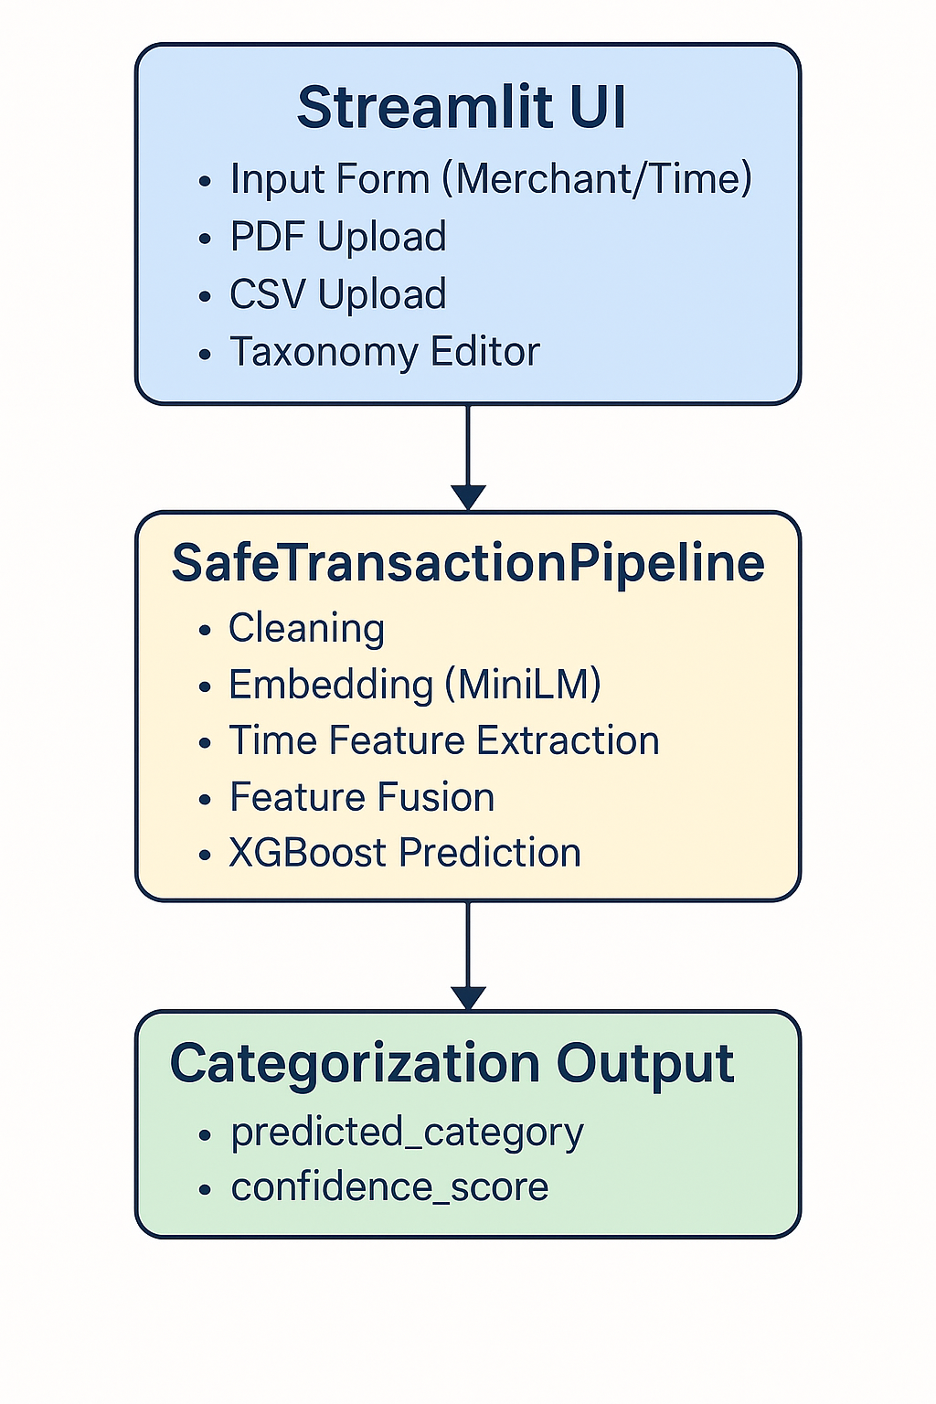
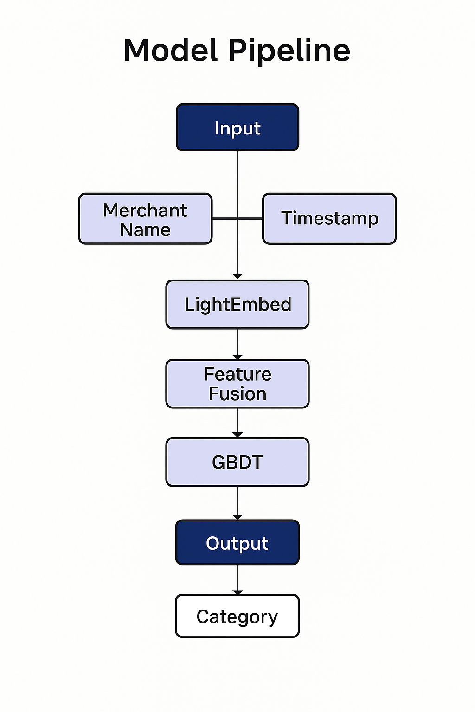
Machine Learning Pipeline:

Links:
Github: https://github.com/klu2300080081/AI-Automated-Transaction-Categorization-System/tree/master

